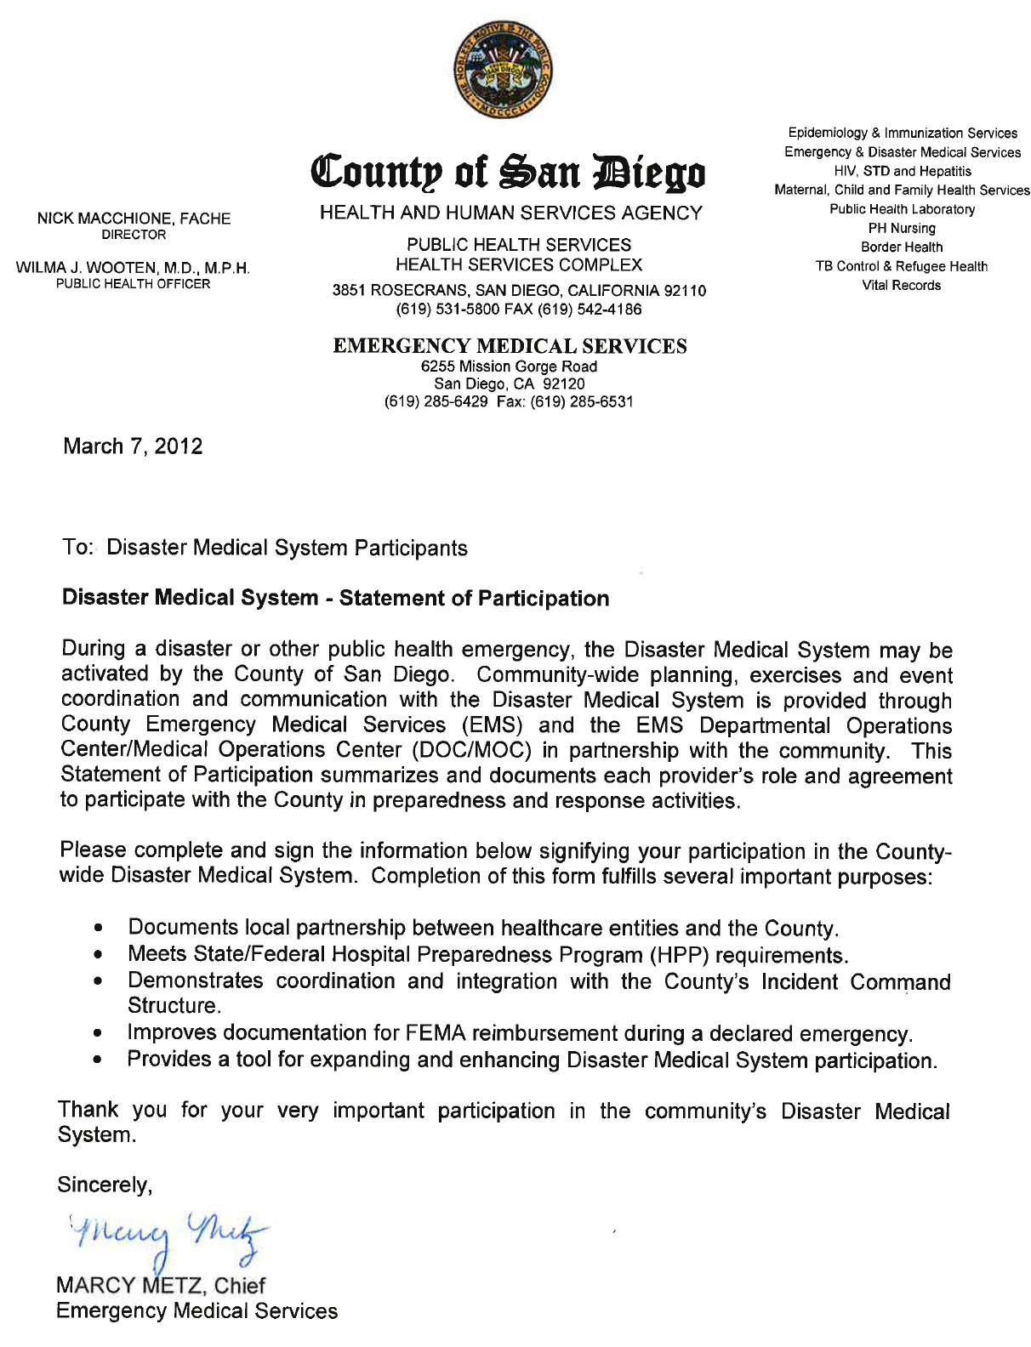
Organization
Organization Name:
Organization Address: |  | City/Zip
Emergency Preparedness (EP) Partnership Lead Contact Information
EP Partnership Lead Name: |  | Lead Phone:
Lead Cell: | Lead Email: | Other:
EP Lead Alternate Name: |  | Alternate Phone:
Alternate Cell: | Alternate Email: | Other:

Hospital Type (check ALL applicable)
- General Acute Care |  | - Behavioral Health/Psych |  | - Rehabilitation
- Hospice |  | - Other |  | - Other
Hospital Services - Disaster Medical System Role (check all applicable)*
- Base Hospital: |  | - Emergency Services |  | - Trauma Center
- Acute Care: Adult |  | - Acute Care: Pediatric |  | - NICU
- Burn Center |  | - Dialysis |  | - Patient Decontamination
- Field Triage/Treatment Teams |  | - ACS Staff/Teams (Govt ACS) |  | - Other:
*As requested by County and subject to hospital capabilities and available resources
Additional Comments:

Participation Agreements (check all that apply)
 | Establish and maintain NIMS compliance (adoption, training, elements)
 | Participate in planning and meetings (e.g., SDHDC, debriefings, ad-hoc workgroups)
 | Emergency Operations Plans consistent with County emergency response plans (e.g., Disaster Medical Services, Mass Fatality, Pandemic, etc)
 | - Primary/redundant communication systems (e.g., WebEOC, 800MHz, Satellite Phone, Ham Radio, etc)
 | - Notifications, communication and information sharing (e.g., EMAN/CAHAN, CASS, WebEOC)
 | - Protocols, systems and forms for requesting and sharing of resources
 | - Reporting hospital status and routine and surge bed capacity in HaVBED categories (e.g., QCS, WebEOC)
 | - Hazard Vulnerability Analysis (HVA) is consistent with county HVA, as appropriate
 | - Staff trained to hospital and community-wide emergency response plans
 | - Work collaboratively with other emergency response providers
 | Activate Emergency Operations Plan (EOP) and Hospital Command Center (HCC) upon notification by County
 | Activate and deploy available resources as requested by/through County incident command structure
 | Participate in at least one annual, community-wide exercise testing partnership elements
 | Participate in exercise/event debriefings
 | Policies addressing special populations and American Disabilities Act (ADA) compliant
Comments:

Signature/Name: |  |  | Title: |  | Date:

