Hospital Continuity Planning Toolkit

Developed by
CHA’s Hospital Preparedness Program
Hospital Continuity Planning Workgroup

October 2012
Preface

The Hospital Continuity Planning Toolkit was developed by the California Hospital Association (CHA) Hospital Preparedness Program’s Hospital Continuity Planning Workgroup. This toolkit was developed to assist and provide examples for hospitals in the development of their business continuity plans. There are multiple methodologies for achieving this and the materials do not represent a mandate or requirement. Rather, the toolkit provides a primary template with detailed instruction, as well as additional tools and templates included in appendixes as examples of supporting documents and representative of additional methodologies. The toolkit is intended as supplemental material to the CHA Hospital Continuity Program Checklist, which can be downloaded from the CHA Hospital Preparedness Program website at www.calhospitalprepare.org/continuity-resources.

Acknowledgments

Lead Toolkit Coordinators

Tracy Robles
Director of Environmental Risk
Sutter Health
Cheryl LaTouche, CBCP
Business Continuity Manager Healthcare Continuity Management
Kaiser Permanente

Hospital Continuity Planning Workgroup

Project Director
Cheri Hummel
Vice President
Disaster Preparedness
California Hospital Association
Project Lead
Ryan Burgess, RN, MSN
Hospital Preparedness Coordinator
California Hospital Association
Project Consultant
Angela Devlen
Managing Partner
Wakefield Brunswick, Inc.
Brandon Bond, MS, EMT, CBCP
Director, Office of Emergency Management
Stanford Hospital and Clinics and Lucile Packard Children’s Hospital
Ray Bonilla Jr., MBA, CBCP, MBCI
Manager, Crisis Management
and Business Continuity
Kaiser Permanente
Sharon L. Carlson
Director of Emergency Preparedness
Sharp HealthCare
Loni Howard
Emergency Preparedness Coordinator
Sutter Medical Center and
Hospital Preparedness Educator
California Hospital Association
Kurt Kainsinger
Disaster Resource Center Manager
UCLA Health System
Marjorie Smallwood
Business Continuity and
Emergency Management Planner
UCLA Health System
Jeremy Stacy
Director of Support Services and Disaster Preparedness Coordinator
Good Samaritan Hospital

Table of Contents

- Introduction 1
- Plan Purpose 1
- Applicability and Scope 1
- Authorities and References 2
- Planning Assumptions 2
- Methodology 4
- Governance 4
- Project Management 5
- Planning Basis (DATA) 6
- Analysis 6
Business Impact Analysis 6
Threat and Risk Analysis 6
- Staffing Needs 6
- Information Technology Applications 6
- Critical Equipment and/or Resources 7
- Vital Records 7
- Department Dependencies 7
- Specifications for Drive-Away Kits 7
- Procedures for Plan Implementation
(INTEGRATION AND PLANNING) 9
- Concept of Operations 9
- Function of the Business Continuity Branch 10
- Utilizing the Business Continuity Plan 10
- Using the Business Continuity Plan Tool 10
The Tiers Tab 10
The Department Tabs 12
- Maintaining Continuity Readiness (execution) 15
- Appendixes 16
- Emergency Management Phase vs. BCP 17
- Glossary of Terms 18
- Business Continuity Flow Chart 22
- Business Continuity Tool 23
D1. Technical Documentation for Maintaining Business
Continuity Plan Tool 24
- Department Status Forms/Summary 33
- Business Continuity Planning (Presentation to Management) 34
- Utilizing Your Business Continuity Plan (Presentation for Department Managers) 35
- Additional Example Plans/Resources 36
- Good Samaritan Hospital: Business Continuity Guide for Critical Business Areas 37
- Kaiser Recovery Checklist 52
- SHARPS Risk Assessment Matrix 58
- Sample Business Continuity Planning Presentation 62

- Introduction

Emergencies, disasters, and other catastrophic events pose a significant threat to the ability of a health care organization to maintain operational capabilities and provide care, treatment, and services to its community.
Although a major catastrophic event could take down a "whole facility," a more likely scenario is that a certain "part" of a facility is substantially damaged by some event (e.g., fire, earthquake, flood, etc.) while the rest of the facility remains functional. However, if the event impacts direct patient service departments for key service lines or mission critical ancillary departments, it may result in adverse impacts to interdependent departments throughout the entire facility. If it takes more than a couple of months to restore service, the organizational consequences could be enormous.
The Emergency Operations Plan (EOP) has been developed to guide the hospital in response to an emergency/disaster situation or a mass casualty incident. Hospital continuity planning augments existing EOPs, strengthening an organization’s capacity to scale their response to a range of events impacting operations. Hospital continuity planning is a proactive process that identifies and prioritizes the critical functions, applications and the measurement of the impact threats to those functions may cause. From this information, plans and procedures are developed through a regular program of personnel training, plan testing, and maintenance. These management disciplines, processes, and techniques provide business continuity for essential functions.
- Plan Purpose
The Business Continuity Plan (BCP) is intended to be a dynamic tool to be used in emergencies, disasters, and other catastrophic events where the technology, building, or a department is severely impacted. The BCP lists critical processes by departments, essential applications, Recovery Time Objectives (RTO), and the resources needed to ensure continuity of operations (i.e., staff, supplies, information technology (IT) applications, etc.). The ultimate goal of business continuity is to resume business functions to a normal state after a period of time following an emergency event.
- Applicability and Scope
A BCP has been developed and will be used in the event of substantial, but relatively localized damage, to direct patient care departments where:
  - The loss of service poses significant physical, operational, and business challenges and risks; and
  - Continuity of the service, somewhere within the facility, is integral to ongoing facility viability and community support.
Affiliates will use the BCP in addition to their Emergency Operations Plan (EOP) to resume/return business functions to a normal state post-disaster. The BCP may be utilized by departments and/or Planning Chief, in coordination with the Business Continuity Branch Director, to develop the Incident Action Plan (IAP).
- Authorities and References
The Joint Commission EM.02.01.01 EP 4
The Joint Commission IM.01.01.03.
The HIPAA Security Rule 164.308(a)(7)(i)
- Planning Assumptions
  - Emergencies can occur suddenly or with some warning period. The organization will be prepared to respond to sudden, potential, or impending emergencies.
  - Emergencies can occur within our hospital (internally), or within our community (externally), that may affect the organization’s ability to provide optimal care, treatment, and/or service.
  - The organization has an EOP that addresses the six critical elements as required by The Joint Commission.
  - The Hospital Incident Command System (HICS) is the management structure that will be used for command and control of an incident.
  - Activation of HICS is determined by the scope and magnitude of the incident and the impact on the facility.
  - The Hazard Vulnerability Analysis (HVA) identifies high-risk hazards that may affect the organization’s services or the ability to provide services. The organization has developed hazard-specific plans for the high-risk hazards.
  - Preserving life, minimizing morbidity and mortality, and minimizing environmental impact are high priorities and are reflected in the organization mission and emergency management program.
  - Maintenance of mission-critical services during emergency response and recovery is a priority.
  - Safety and security of personnel, patients, visitors, and volunteers is the top priority during emergency response and recovery.
  - This organization will maintain communications, collaboration, and cooperation with community response partners including: the local Emergency Operations Center (EOC), Joint Information Center (JIC), area hospitals, and others involved in the incident.
  - Adequate training is given on the use of the program and all staff are made aware of its existence and their roles within the program.
  - During a disaster, staff will be considered essential emergency workers and may be reassigned to other duties as necessary.
  - It may be necessary to share resources with other hospitals, health care partners, and response agencies to accomplish a successful outcome in an emergency.
  - The program is tested and reviewed on a regular basis.
- Methodology

The methodology used in developing a Business Continuity Plan (BCP) consists of the following key elements (Note: the process each hospital uses is tailored based on specific objectives set by hospital priorities).
- Governance
Scope Definition: Establish and meet with the steering committee and determine what they want to know as a result of the business continuity planning process and what decisions they need to make.
Executives are responsible for:
  - Market share in a highly competitive health care environment
  - Extensive regulations
  - Profitability in a low margin industry
  - Operational improvements
  - Community and board relations
Executives are liable for:
  - Interruptions to health services resulting in:
    - Adverse impacts to patient safety and reputation among community and board members
    - Loss of market share (patients go to alternate provider for care) and/or revenue
    - Regulatory fines and corrective actions
  - Adverse impacts resulting from:
    - Security breaches and IT downtime
    - The loss of business-critical information or patient health information
The organization’s senior management team is responsible for overseeing the business continuity planning process, which includes:
  - Establishing policy by determining how the organization will manage and control identified risks;
  - Allocating knowledgeable personnel and sufficient financial resources to properly implement the BCP;
  - Ensuring that the BCP is reviewed and approved at least annually;
  - Ensuring employees are trained and aware of their roles in the implementation of the BCP;
  - Reviewing the BCP testing program and test results on a regular basis; and
  - Ensuring the BCP is continually updated to reflect the current operating environment.
- Project Management
  - Form a multi-disciplinary oversight team to oversee completion of business continuity profiles and action plans. Members of the team may include the COO, CNE, CFO, CIO, or their designee, Emergency Preparedness Coordinator, the Safety Officer, and other selected key service line and ancillary department managers.
  - Collect a list of all departments and associated cost centers from finance. Departmental data is required initially to identify the list of departments needed to complete a business continuity profile.
  - Provide education to selected department leaders explaining the purpose of business continuity planning and how to complete a business continuity profile.
  - Upon completion, the department leader will submit the completed business continuity profile to the oversight team for review and approval.
  - The oversight team utilizes business continuity profiles to complete the BCP template.
- Planning Basis (Data)

- Analysis
A number of analyses are conducted to determine essential functions, Recovery Time Objectives (RTO), and threat/risks.
Business Impact Analysis
A Business Impact Analysis (BIA) results in the identification and prioritization of essential functions. An essential function is a series of logically-related activities or tasks that, when performed together, produce a defined set of results. A business process is considered critical if it creates or possesses value for the department’s stakeholders. The impairment of this process disrupts operations and does not meet customer needs, satisfy mandatory regulations/requirements or allow the execution of the organization’s mission. For example, triage is considered an essential function of the emergency department.
Each department within the hospitals should conduct a review of current operations and identify the essential functions needed to perform patient care services and maintain operations. Essential functions should then be prioritized so that essential services can be restored and resources can be allocated effectively. For each essential function, a RTO is assigned. A RTO is considered the maximum amount of downtime that is allowable for a critical process before the impact becomes severe enough to drastically hinder patient safety and/or stop the continuation of business services.
Threat and Risk Analysis
A review of the Hazard Vulnerability Analysis (HVA) is conducted to identify threats and risks that pose a hazard to the operations of the hospital and the information technology (IT) infrastructure. Understanding potential events allows the hospital to plan and mitigate or eliminate the impacts of these events.
- Staffing Needs
In an emergency, the number of staff required to perform essential functions is largely determined by the priority emergencies identified as a result of the organization’s HVA, as well as the reporting relationships in the command and control operations of the organization. Departments must identify which staffing positions are required for each operational period and whether the staffing positions need to be physically on site or can telecommute.
- Information Technology Applications
IT continuity planning is a coordinated strategy involving plans, procedures, and technical measures that enable the recovery of IT systems, operations, and data after a disruption. Contingency planning generally includes one or more of the approaches to restore disrupted IT services:
  - Restoring IT operations at an alternate location;
  - Recovering IT operations using alternate equipment; and/or
  - Performing some or all of the affected business processes using non-IT (manual) means (typically acceptable for only short-term disruptions).
- Critical Equipment and/or Resources
On a daily basis, hospitals maintain a general inventory of supplies and equipment needed to perform essential functions. It is essential that necessary equipment/resources are identified to ensure critical processes are operational within a specified operational period.
- Vital Records
Vital records are an essential resource and should be addressed in department continuity plans. Vital records are computerized or paper records that are considered essential to the continuation of the business following an incident.
Categories of recorded data that typically fall under the category of vital may include:
  - Patient health care records, controlled drug administration, and results of clinical trials
  - Birth records, court records, and vital statistics
  - Contracts/agreements that prove ownership of property and equipment
  - Operational records such as accounting records, architectural drawings, shipping delivery records, software licenses, and maintenance contracts
  - Current client files and account information
  - Intellectual property such as source code, formulas, schematics, and standard operation procedures
  - Legal documents such as tax records, and correspondence or other documents which are part of ongoing litigation
- Department Dependencies
Other departments provide a multitude of services that are needed to ensure an essential function is operational. These other departments may be internal ancillary services such as imaging or the laboratory. External dependencies may exist as well, for example, a courier or mobile dialysis service.
- Specifications for Drive-Away Kits
A “drive-away kit” should be prepared by individuals who expect to deploy to an alternate location during an emergency. It is sometimes also referred to as a “go-kit.” A drive-away kit should contain those items a team member considers essential to supporting operations at an alternate site. Each kit may be somewhat unique, but most should include items such as:
  - Continuity checklists
  - Key contact lists (names, phones, addresses, etc.)
  - Files specific to the member’s position that will be important to an effective response capability
  - Tools routinely used by the member
  - Maps to alternate sites
- Procedures for Plan Implementation
(Integration and Planning)

- Concept of Operations
Upon activation of the Hospital Incident Command System (HICS), the Incident Commander (IC) will provide an initial briefing to the Command Staff and Section Chiefs. During that time the IC will utilize the HICS Incident Response Guide (IRG) to make initial assignments and to establish control objectives and set the operational period. The Section Chiefs and Branch Directors will then determine the specific operational period objectives for each section.
  - Control objectives are the overall broad objectives based on the priorities of:
    - Incident stabilization
    - Life-saving actions
    - Property preservation that additionally honor organizational and jurisdictional priorities (if they exist)
    - Business continuity
  - Operational period objectives:
    - Are more specific strategic and tactical objectives that assist in achieving the control objectives
    - Should be Simple, Measurable, Achievable, Realistic, and Time Sensitive (SMART)
    - Are brief and easy to understand
  - An operational period is the period of time in which a given set of tactical actions or operational period objectives will be completed.
The Planning Chief will facilitate a planning meeting to discuss the operational period objectives, strategies and tactics to accomplish the objectives, determine resources needed, and assign tasks.
An Incident Action Plan (IAP) will be developed to reflect the overall incident strategies and actions to be taken during a specific operational period.
Each department will assess the status of their area to determine continuity of operations by completing a “department status form” (see appendix E). Upon completion, the form will be submitted to the Planning Chief. The Planning Chief will collect and evaluate the department status forms and provide a report to the IC. The IC may activate the Business Continuity Branch to ensure continuity of operations as needed.
- Function of the Business Continuity Branch
The function of the Business Continuity Branch is to assist impacted areas with ensuring that critical business functions are maintained, restored, or augmented to meet the designated Recovery Time Objective (RTO) and recovery strategies outlined in the areas’ Business Continuity Plan (BCP). The Business Continuity Branch activities include:
  - Evaluation of the impacted areas to ascertain business function capability
  - Facilitate the acquisition of and access to essential recovery resources
  - Support the Infrastructure and Security Branches with needed movement or relocation to alternate business operation sites
  - Coordinate with the Logistics Section to obtain communication and information system hardware
  - Assist other branches and impacted areas with the restoring and resuming of normal operations
- Utilizing the Business Continuity Plan
Upon activation of the Business Continuity Branch, the Business Continuity Branch Director, in collaboration with the manager(s) from the impacted departments, will use the BCP to identify resources needed to ensure continuity of critical processes within the RTO.
The Planning Section will include recovery objectives in the Incident Action Plan (IAP). Upon completion, the IAP will be approved by the IC and communicated to other HICS sections/positions as applicable.
- Using the Business Continuity Plan Tool
The BCP Tool was developed for the Hospital Command Center (HCC) to use during an incident. The HCC can use this Microsoft Excel worksheet to track which critical business processes are operational, if there is a workaround available, and available resources.
The Business Continuity Branch Director, in collaboration with the department manager(s), will utilize the BCP Tool to determine department needs. Upon completion, the Director will forward the document to the Planning and Logistic Sections to take appropriate action as needed.
The BCP Tool is segmented into multiple tabs — the tiers tab and numerous department tabs. The purpose of each tab is described below.
The Tiers Tab
Critical processes are prioritized into tiers based on operational periods:
  - Tier 1 (0-2 hours)
  - Tier 2 (2-12 hours)
  - Tier 3 (12-24 hours)
  - Tier 4 (1-3 days)
  - Tier 5 (4-7 days)
  - Tier 6 (8-14 days)
  - Tier 7 (15-30 days)
  - Tier 8 (31+ days)
For each operational period, the tiers tab lists each department alphabetically and prioritizes their critical business functions/processes. Recovery strategies would be implemented for “Priority 1” items before the “Priority 2” items and so on. The significance of prioritizing is to aid the IC, Section Chiefs, and Business Continuity Branch Director in establishing operational period objectives and identifying resources.
Exhibit 1
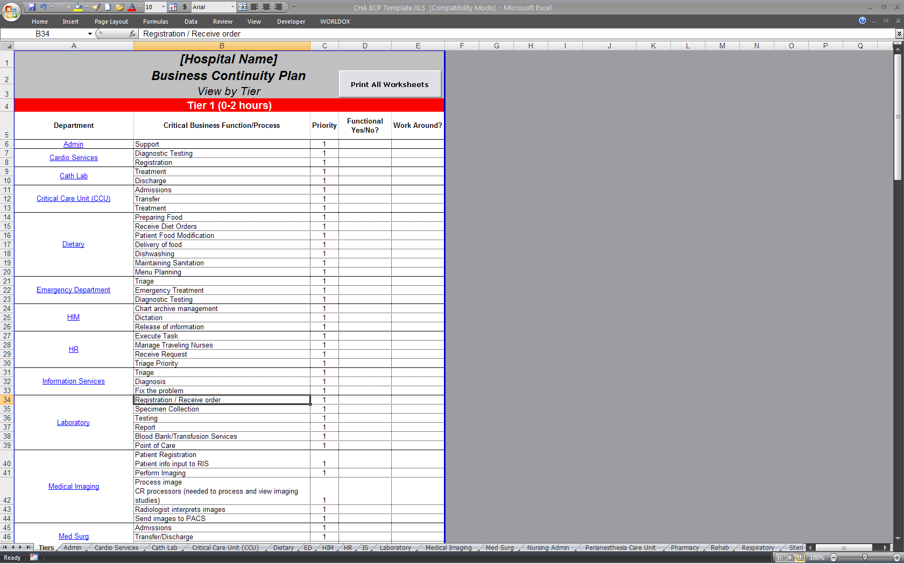
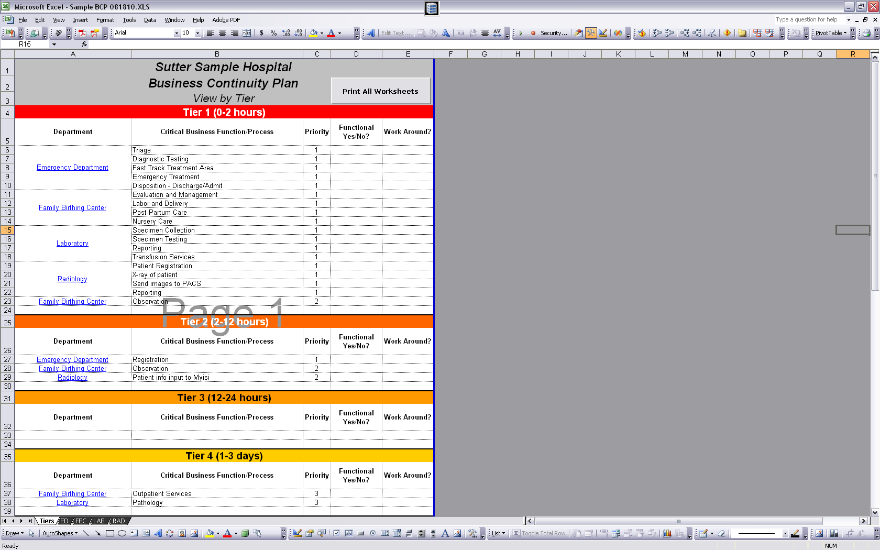
Specific department information can be accessed by either clicking on the department name (circled in green above) on the tiers tab or navigating to the corresponding tab.
All the information in the department tabs can be printed by clicking the “Print All Worksheets” button in the top right corner (shown above in the blue square).
The Department Tabs
Each department tab contains the following sections:
  - Critical Business Processes
  - Critical Equipment or Resources
  - Technology and Equipment Critical Processes
  - Staffing Positions
  - Critical Records
  - Departmental Dependencies
Exhibit 2
A
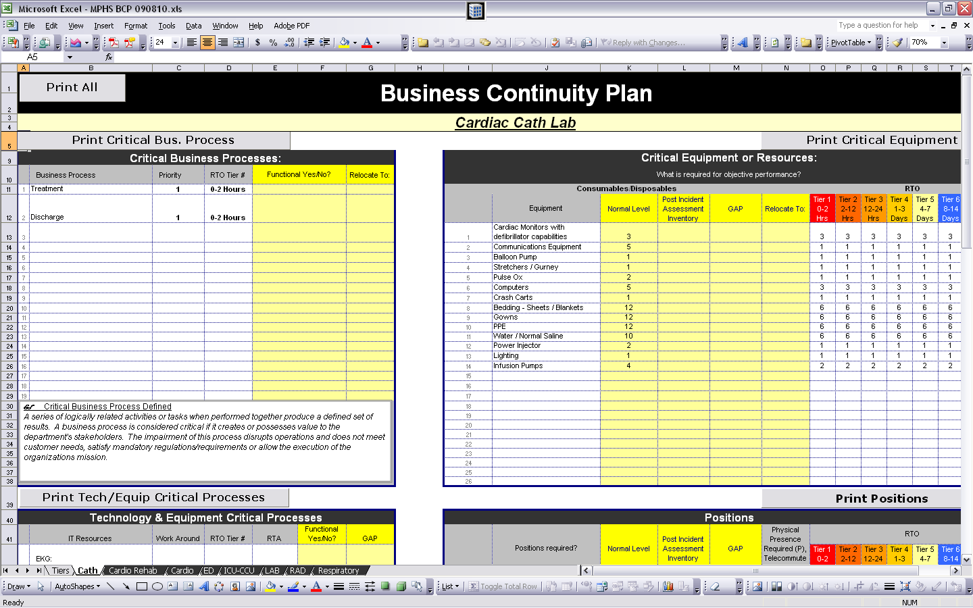
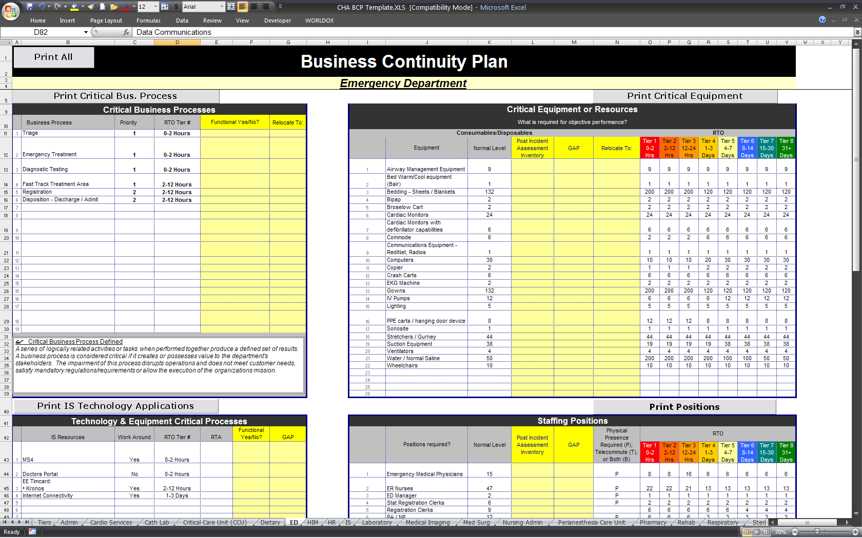
B
C

D

E

F

Overall View
Black arrow (A) — Prints all sections of the BCP for this department.
Blue arrow (B) — Shows which department the sheet is referencing.
Critical Functions
Red arrow (C) — Prints the “Critical Functions” section.
Green arrow (D) — Lists and prioritizes critical functions to provide patient care.
Critical Equipment or Resources
Purple arrow (E) — Prints the “Critical Equipment or Resources” section.
Orange arrow (F) — Denotes what equipment/resources are needed to ensure critical processes are operational within a specified operational period:
  - Type of Equipment
  - Normal Levels
  - RTOs
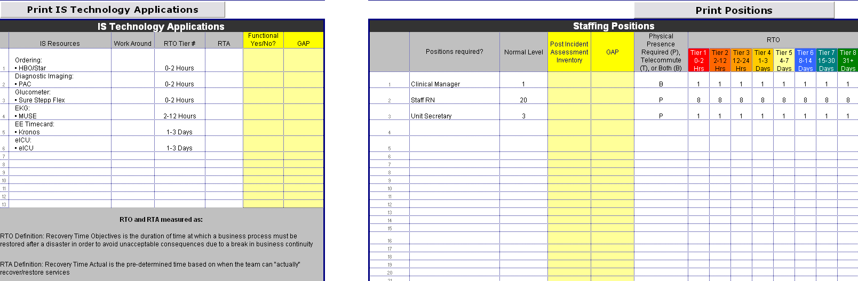
Exhibit 3
G
I
J
H

Information Technology Applications
Red arrow (G) — Prints the “IS Technology Applications” section.
Yellow arrow (H) — Lists the technology needs of the departments:
  - IT Resources
  - Workaround availability
  - RTO Tiers
  - RTA
Staffing Positions
Purple arrow (I) — Prints the “Critical Positions” section.
White arrow (J) — Designates which staffing positions are required for each operational period and identifies whether the staffing position has to be on site or can telecommute.
Exhibit 4
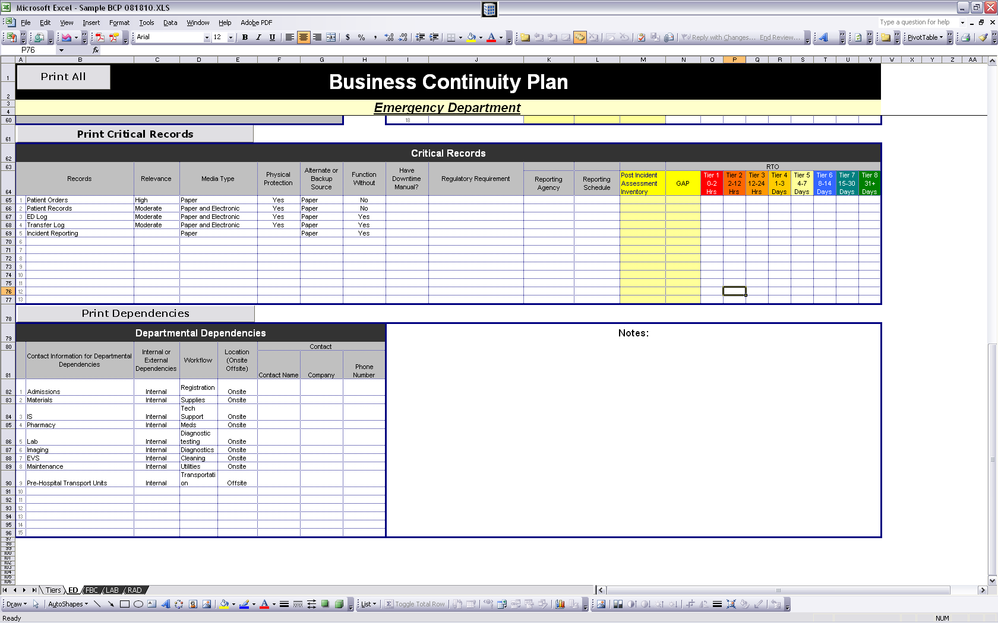
L
K
N
M
Critical Records
Purple arrow (K) — Prints the “Critical Records” section.
Light Green arrow (L) — Lists the critical records that are required for that department:
  - Type of record
  - Relevance of records
  - Media type
  - Physical protection
  - Alternate or backup source
  - Function without
  - Have downtime manual
  - Regulatory requirements
  - Reporting agency
  - Reporting scheduling
  - RTO requirements
Departmental Dependencies
Brown Arrow (M) — Prints the “Department Dependencies” section.
Light Blue arrow (N) — Lists “other” departments that are needed to ensure that the critical process is operational, including the following:
  - Internal vs. external
  - Location
  - Contact information

- Maintaining Continuity Readiness (Execution)

An organization-wide business continuity testing program should be established by the continuity oversight team. The testing program should:
  - Incorporate testing strategies to address the results of the business impact analysis and the risk assessment;
  - Identify key roles and responsibilities; and
  - Establish minimum requirements for the organization’s business continuity testing, including baseline requirements for frequency, scope, and reporting test results.
At a minimum, the testing scope and objectives should:
  - Not jeopardize normal business operations;
  - Gradually increase in complexity, level of participation, functions, and physical locations involved;
  - Demonstrate a variety of management and response proficiencies under simulated crisis conditions, progressively involving more resources and participants; and
  - Uncover inadequacies so that testing procedures can be revised.

- Appendixes

Appendix A
Emergency Management Phase vs. BCP

Phase | Emergency Management Components | Business Continuity Component (from DRII Professional Practices)
Mitigation | - Threat and Hazard Vulnerability Assessment | - Risk Assessment  - Business Impact Analysis
Preparedness | - Hazard Mitigation Planning  - Emergency Operations Planning  - Business Continuity  - Communications (Alert/Warning)  - Hazard Specific Annexes (Flood, Hurricane, Terrorism, etc)  - Long Term Recovery Planning  - Training and Exercise programs | - Developing Business Continuity Strategies  - Developing and Implementing Business Continuity Plans  - Awareness and Training Programs  - Maintaining and Exercising Plans  - Crisis Communications  - Coordination with External Agencies
Response | - Levels of Activation  - NIMS and ICS  - Public Safety  - Incident Stabilization | - Emergency Response and Operations  - Components of Emergency Response  - Roles and Responsibilities: Incident Command  - HICS and the Business Continuity Branch Director  - Emergency Operations Centers  - Plan Activation  - Recovery and Resumption of normal hospital operations
Recovery | - Mass Care  - Sheltering  - Finance: Reimbursement & Cost Recovery

Appendix B
Glossary of Terms

Application — The software that serves a business or clinical function.
Application “cloud” — The use of distributed storage and processing on servers connected by the internet, typically provided as software or data storage as a subscription service provided by other companies.
Application Recovery — The component of recovery that deals specifically with the restoration of system software and data, following the replacement and restoration of the processing platform and equipment.
Business Continuity — The ability of an organization to ensure that essential functions and supporting applications will be available to employees and patrons following a disruptive event.
Business Continuity Plan — The business continuity plan is a document that defines recovery responsibilities and resources necessary to respond to a disruption to business operations.
Business Continuity Planning (BCP) — An all-encompassing, “umbrella” term used to describe the comprehensive process of planning for the recovery of operations in the event of a disruptive event.
Business Continuity Program — Set of standard planning guidelines and procedures for the development of Business Continuity Plans throughout the Enterprise.
Business Impact Analysis (BIA) — A review of current operations, with a focus on business and clinical essential services, to determine the effect that a business disruption would have on normal business operations. Impacts are measured in either quantitative or qualitative terms. This information is used to drive the recovery planning process, the potential recovery solutions and the amount of expenditure required to support the backup of certain business operations. The BIA identifies critical hospital functions and supporting technology and support functions necessary to meet the Recovery Time Objective (RTO) and Recovery Point Objective (RPO).
Continuity of Operations (COOP) — A predetermined set of instructions or procedures that describe how an organizations essential functions will be sustained for up to 30 days as a result of a disaster event before returning to normal operations. Usually refers to government agencies.
Critical Process — Business activities or information which could not be interrupted or unavailable for several business days without significantly jeopardizing operation of the organization.
Criticality — Departments are responsible for understanding how quickly their operations should be restored following a business disruption. Planning Coordinators should consider not only potential direct financial loss, but also loss of customers or market share, loss of investor confidence, damage to public perception of the company, and regulatory and legal penalties.
Department — A patient care unit, a business unit or support services to carry out the functions across hospital, research and foundation organizations.
Disaster Recovery — The coordinated process, policies, and procedures that enable the recovery of IT systems and hospital essential functions following a disruption.
Disaster Recovery Plan — The management approved document that defines the resources, actions, tasks, and data required to manage the technology recovery effort. Usually refers to the technology recovery effort. This is a component of the Business Continuity Management Program.
Downtime Manual — A document created by a department that contains detailed procedures to conduct essential functions during IT downtime.
Downtime Procedures — The specified actions or operations that are executed during the period in which essential functions or supporting applications are non-functional during a disruptive event.
Essential Application — The information or software application needed to support essential functions.
Essential Function — The three most important things that a department does to provide services to patients or administration. A primary business process comprised of one or more business functions that represents a key element of current business operations. Business processes will typically be identified at the Plan Unit level.
Essential Personnel — An employee whose duties are of such a nature as to require the employee to report to work or remain at the work site to continue agency operations during an emergency situation.
Family Experience — The effect a disruptive event will have on the quality of attention and work patients and their families receive.
Financial Impacts — An operating expense that continues following an interruption or disaster, which, as a result of the event, cannot be offset by income and directly affects the financial position of the organization.
Joint Commission Standard IM.01.01.03 — The health care standard that addresses continuity and disaster recovery for both hard copy and electronic records.
Network Outage — A disruption in system availability as a result of a communication failure affecting a network of computer terminals, processors, or workstations.
Operational Impact — The effect a disruptive event will cause to operations (non-quantifiable in financial terms).
Patient Safety Impact — The effect a disruptive event will cause to the safety of the patients (non-quantifiable in financial terms).
Recovery Period — The time period between a business disruption and a return to normal functions, during which the BCPs are employed.
Recovery Point Objective (RPO) — The point in time to which data must be restored in order to resume processing transactions. RPO is the basis on which a data projection strategy is developed.
Recovery Procedures — Recovery procedures are contained within the team continuity plan. They document the actions and activities that are necessary to recover normal business operations following a business disruption. Common recovery procedures include:
  - Restoration of all previously identified essential business records
  - Relocation of business operations to an alternate or repaired location
  - Re-creation of lost work-in-progress
  - Restoration of backup information that is stored off-site
Recovery Solution — Pre-planned recovery resource acquisition techniques. Recovery solutions describe techniques for replacing furniture, equipment, supplies, as well as the restoration of information. Sample recovery solutions include:
  - Purchase at time of business disruption
  - Storage of backup equipment off site
  - Contract for shippable equipment (drop ship agreements)
  - Utilizing existing available equipment at an recovery location
Recovery Time — The period from the business disruption to the recovery.
Recovery Time Actual (RTA) — The actual time it takes to bring up a technological critical process.
Recovery Time Objective (RTO) — The time it takes to restore data and system/application functionality that must be restored in order to resume processing transactions.
Risk Assessment — The process of identifying and minimizing the exposures to certain threats, which an organization may experience. There are four steps in the risk assessment process:
  - Identify any control weaknesses and/or single points of failure
  - Identify the risks
  - Identify one or more countermeasures, with estimated implementation costs, which could be implemented to mitigate the identified risks
  - Select and implement the most appropriate countermeasure
Risk Quadrant — Once this risk is assessed, this is used to plot the impact and likelihood of the risk occurring. Allows one to visualize risks in relation to each other, gauge their level, and plan what type of controls should be implemented to mitigate the risks.
Scope — Predefined areas of operation for which a BCP is developed.
System Downtime/Outage — An unplanned disruption in system availability as a result of computer hardware or software problems or operational problems.
Tiering — Grouping of services and applications according to the RTO and RPO metrics.
Vital Records — Records or documents, for legal, regulatory, or operational reasons, cannot be irretrievably lost or damaged without materially impairing the organization's ability to conduct business.
Workaround Measures — Also known as “downtime procedures.” Formal procedures and supporting documents or forms to ensure the unit continues its operations during an IT outage.

Appendix C
Business Continuity Flow Chart

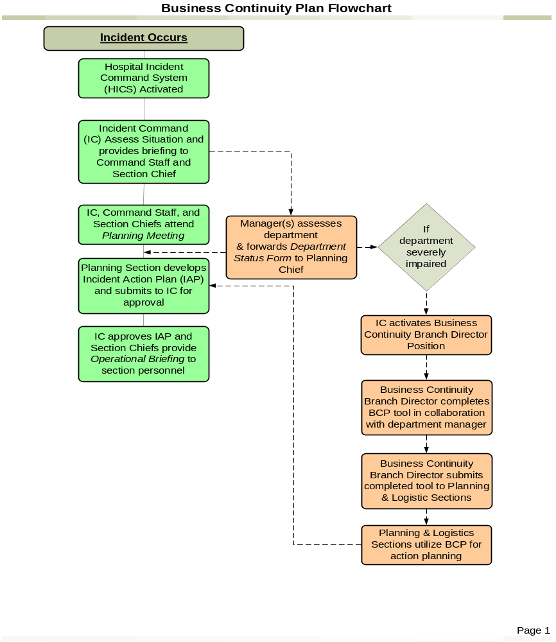

Appendix D
Business Continuity Tool

Hold down your Ctrl key and click here to download the Business Continuity Tool
or go to www.calhospitalprepare.org/continuity-resources.
(Note: File is large and can take a few minutes to open.)

Appendix D1
Technical Documentation for Maintaining Business Continuity Plan Tool

- Overview
The Business Continuity Plan Tool has some basic technical “coding” built into the spreadsheet using Microsoft’s™ Visual Basic (VB). The “coding” is associated with the print buttons for each of the sections (Critical Business Processes, Critical Equipment or Resources, Technology and Equipment Critical Processes, Staffing Positions, Critical Records, and Departmental Dependencies) within the department tab, as well as the Print All Worksheets button on the Tiers tab. The maintenance of the code is fairly easy for any non-technical person to update however, as a best practice, save a copy of the Business Continuity Plan Tool until there is a level of comfort in making changes with the “code.”

This section will cover the technical maintenance of the Business Continuity Plan Tool.
- Adding Rows to the Business Continuity Plan Tool
The Microsoft™ VB “code” requires that on all of the department tabs, each section have the same amount of rows to ensure proper printing when the Print buttons (Exhibit 1) are utilized.
Exhibit 1: 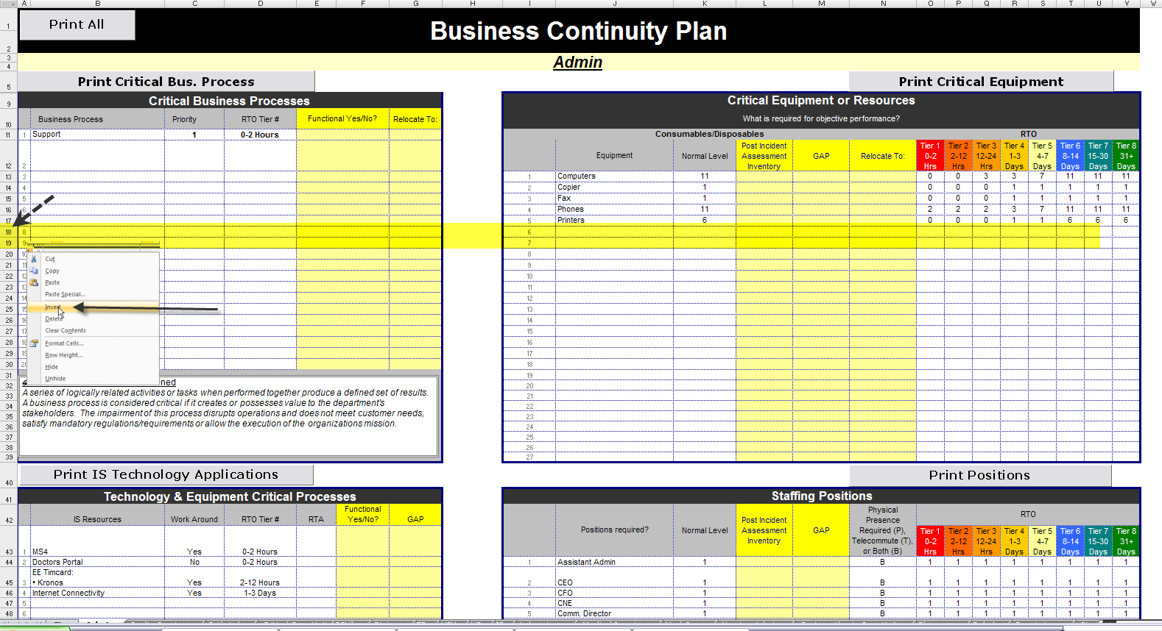

For the purposes of the Microsoft™ VB “code,” the Critical Business Processes and Critical Equipment or Resources are considered one “section,” the Technology & Equipment Critical Processes and Staffing Positions is another continuous “section,” the Critical Records is a “section,” and Departmental Dependencies is the last “section.”

For example, within Exhibit 2 each of the Department tabs (Admin, Cardio Services, Cath Lab, and so on):

Black section (A) — The Critical Business Processess and Critical Equipment and Resources sections start at row 9 and ends at row 39
Blue section (B) —The Technology & Equipment Critical Processess and Staff Positions sections start at row 41 and ends at row 60
Red section (C) —The Critical Records section starts on row 62 and ends on row 77
Green section (D) —The Departmental Dependencies section starts on row 79 and ends on row 102
It is important when adding rows to the spreadsheet within the sections listed in Exhibit 2, the same amount of rows are also added to the corresponding section; for example, rows added to Critical Business Processes are also added to Critical Equipment sections, and rows added to Technology & Equipment Critical Processess are also added to Staff Positions sections, etc.
Exhibit 2
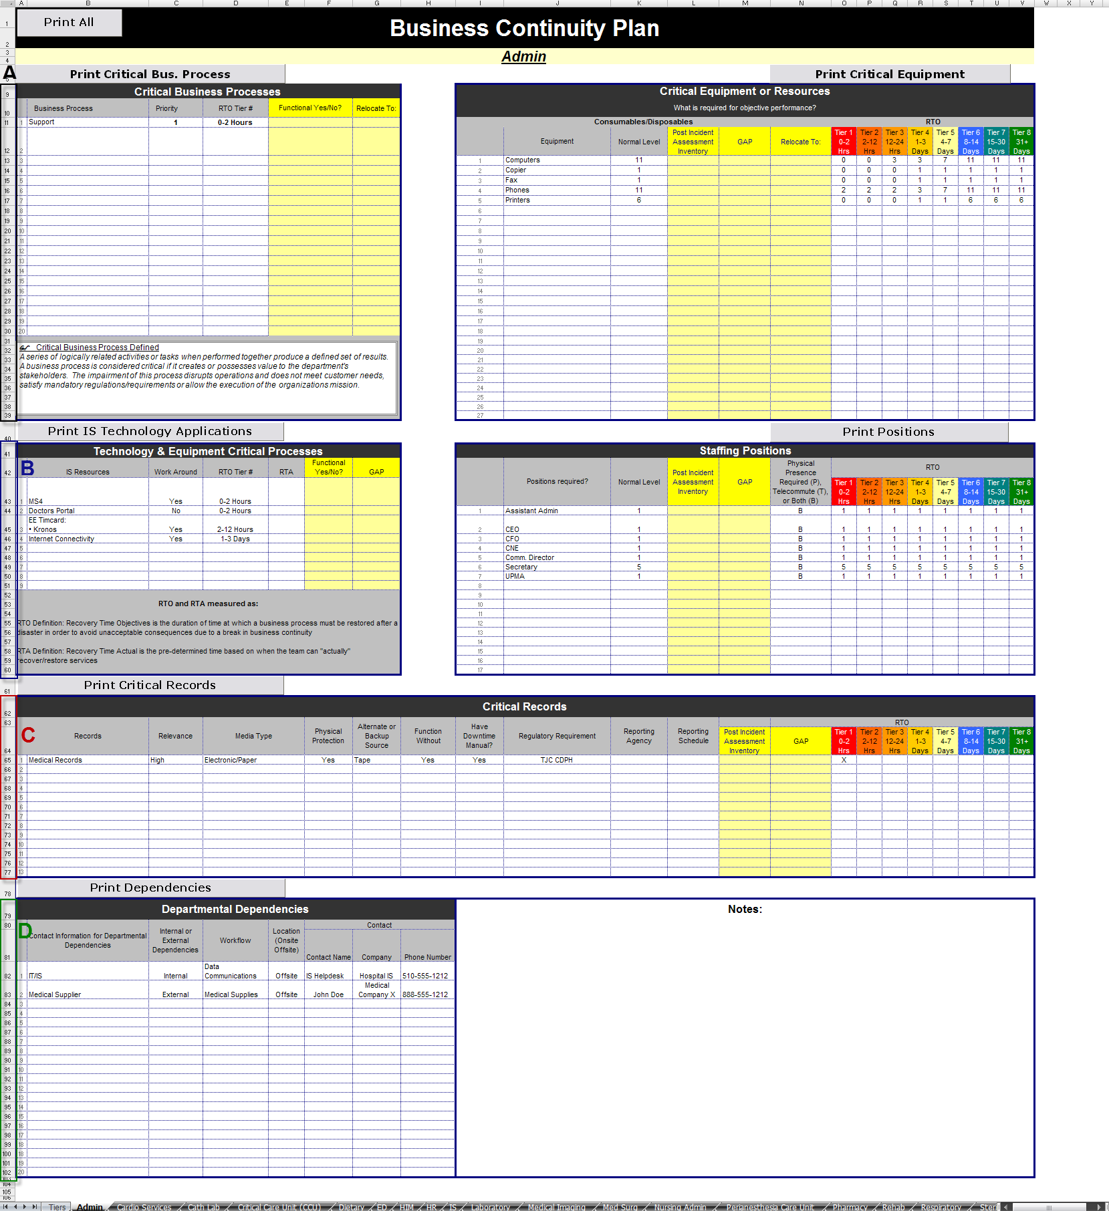

Spreadsheet rows can be added to the department tabs all at once. To add row(s) to the spreadsheet in the department tabs, select/group each department tab by holding down the “Control” key on the keyboard and left click each tab with the mouse. When the department tabs are selected/grouped, the tabs will change color to white:
Exhibit 3
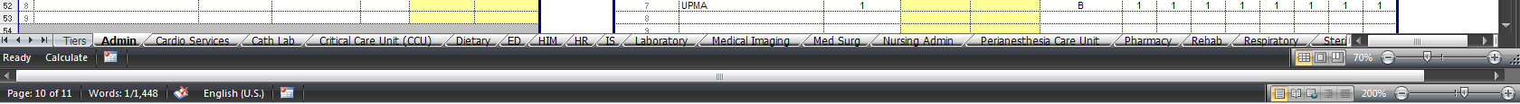

Insert a row in the spreadsheet by right clicking on the Excel row where the data needs to be added, select“Insert” on the menu. Within all of the department tabs (as demonstrated in Exhibit 4), two rows (row 18 and row 19) were added to both of the Critical Business Process and Critical Equipment and Resources sections simultaneously.
Exhibit 4

Review the each of the department tabs where the spreadsheet rows were added, check any for formatting problems such as merging any cells that unmerged in the insertion of the rows (blue box) and adding any numbers missing (red box).
Exhibit 5
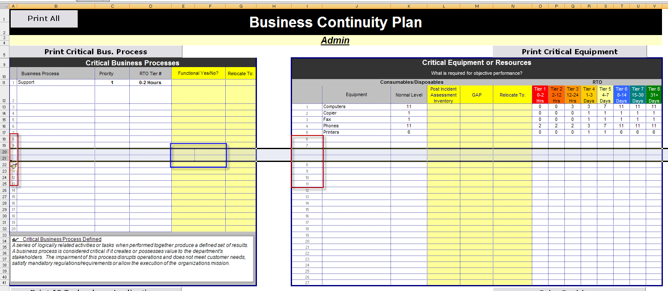

Each section in Exhibit 6 (Critical Business Processes, Critical Equipment or Resources, Technology and Equipment Critical Processes, Staffing Positions, Critical Records, and Departmental Dependencies) now has an updated “location” on each of the department tabs within the spreadsheet:
Black section (A) — The Critical Business Processess and Critical Equipment and Resources sections now starts at row 9 and ends at row 41
Blue section (B) —The Technology & Equipment Critical Processess and Staff Positions sections now starts at row 43 and ends at row 62
Red section (C) —The Critical Records section now starts on row 64 and ends on row 79
Green section (D) —The Departmental Dependencies section now starts on row 81 and ends on row 104
Exhibit 6
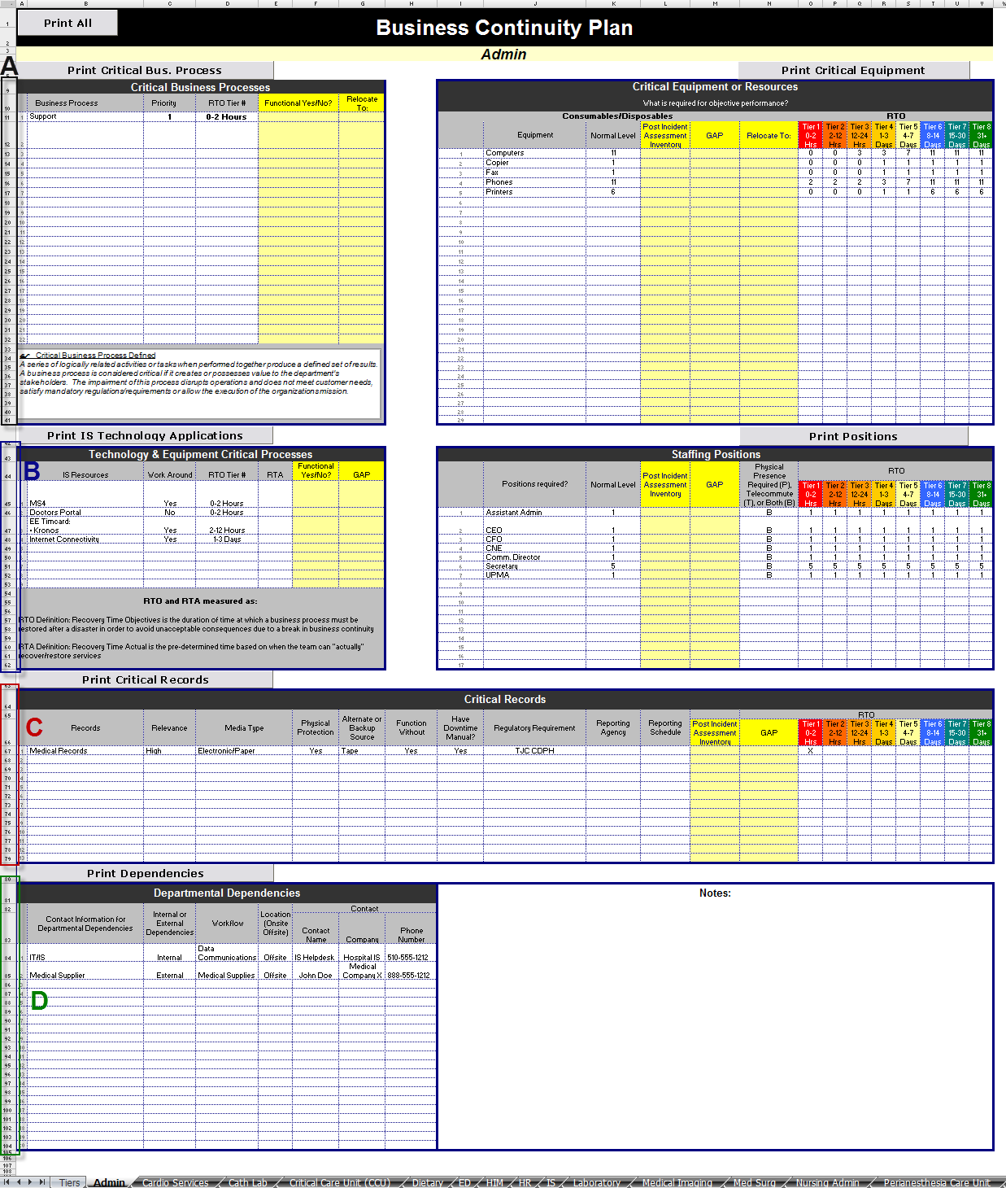
WARNING: When Excel tabs are “selected/grouped,” any data entered into an Excel cell will overwrite data on all selected/grouped tabs. After resolving any formatting issues, it is always best practice to “unselect/ungroup” the department tabs to prevent any data within the Business Continuity Plan being overwritten. To ungroup selected tabs, right click on a “selected/grouped” tab and choose “Ungroup Sheets”; the tabs will change to white from their normal color:
Exhibit 7
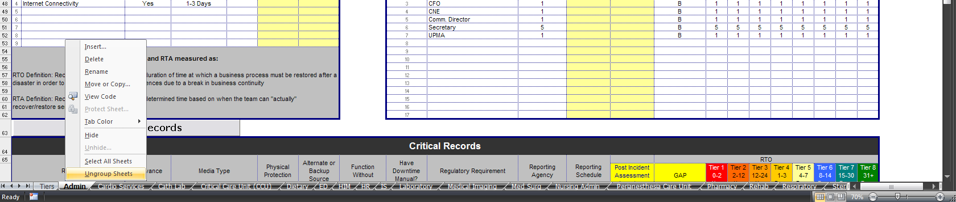
- Modifying the Microsoft™ VB “code”
Subsequently, the Microsoft™ VB “code” will require updating so the print buttons will print the added rows on each of the department tabs (as shown in Exhibit 7). To update the Microsoft™ VB “code,” right click on any of the Excel tabs and choose the menu option “View Code.” A new program will open (as shown in Exhibit 9) where the “code” can be updated.
Exhibit 8
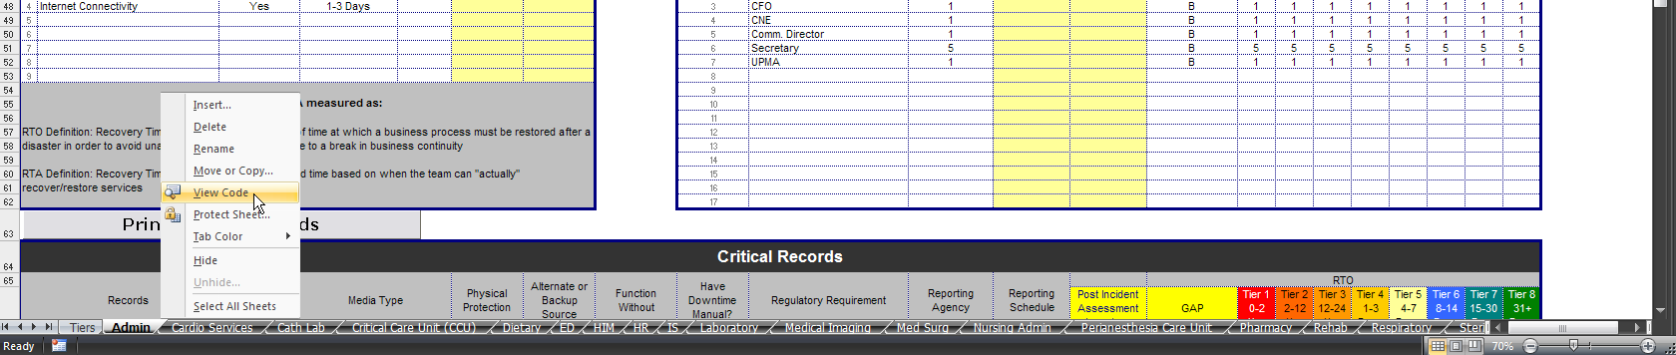

To navigate to the Microsoft™ VB “code” that controls the print buttons, open the “Modules” folder and double-click on “basPrintOptions.”
Exhibit 9
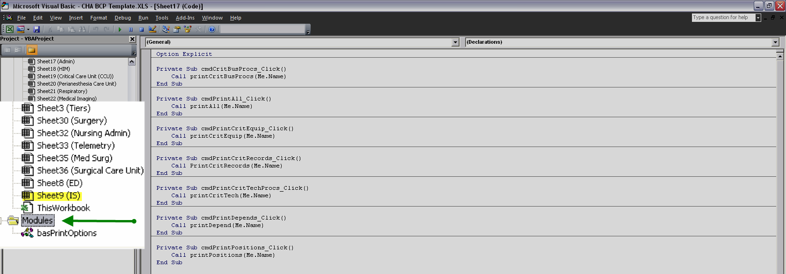
The Microsoft™ VB print module “code” will display for the Business Continuity Plan Tool. This area is the only locations within the Microsoft™ VB “code” which needs to be updated for the Business Continuity Plan Tool to function properly.
WARNING: Modifying other lines within the “code” outside of what is outlined in this document, will change how the Business Continuity Plan Tool is laid out. As a best practice, save a copy of your original Business Continuity Plan Tool template before testing modifications on other aspects not described in the next section.
Exhibit 10
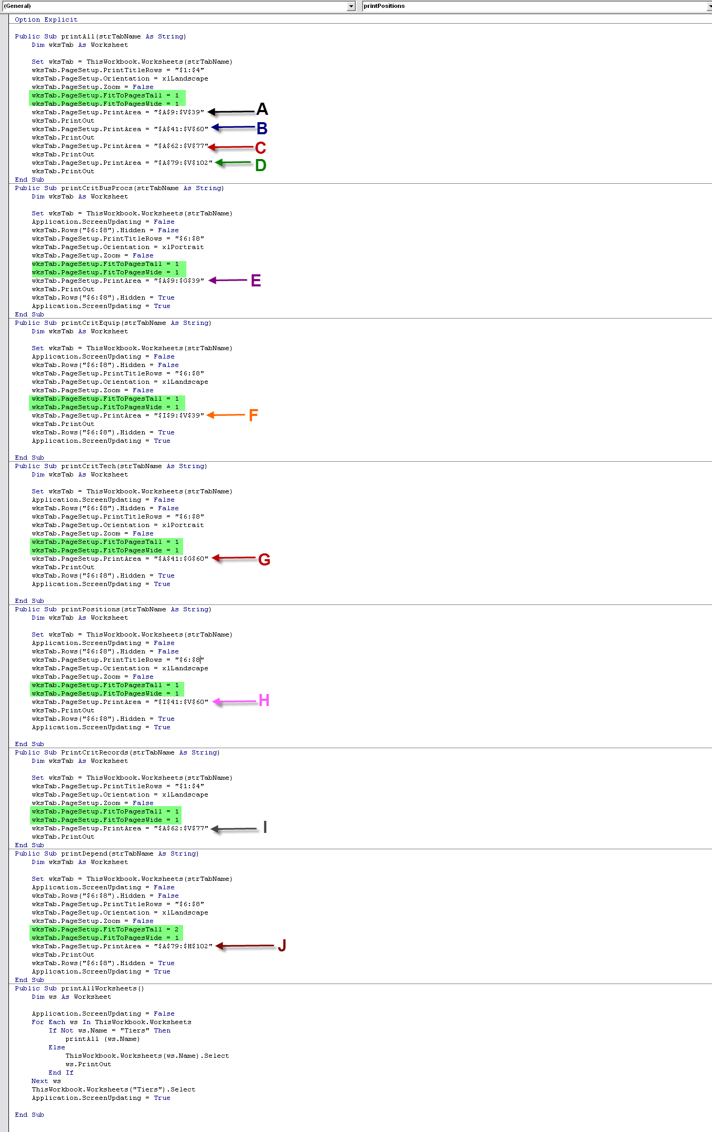
The sections A through D control the “code” for the print button on the Tiers tab. Within Microsoft™ VB “code,” the rows for the department sections are denoted as:
Black section (A) — Critical Business Processes and Critical Equipment and Resources sections
Blue section (B) —Technology & Equipment Critical Processess and Staff Positions sections
Red section (C) — Critical Records section
Green section (D) — Departmental Dependencies section

The sections E through J control the “code” for the print button on all of the Department tabs. Within Microsoft™ VB “code,” the rows for the department sections are denoted as:
Purple section (E) — Critical Business Processes section (only)
Orange section (F) — Critical Equipment and Resources section (only)
Dark Red section (G) — Technology & Equipment Critical Processess section (only)
Pink section (H) — Staff Positions section (only)
Gray section (I) — Critical Records section (only)
Brown section (J) — Departmental Dependencies section (only)

Exhibit 11
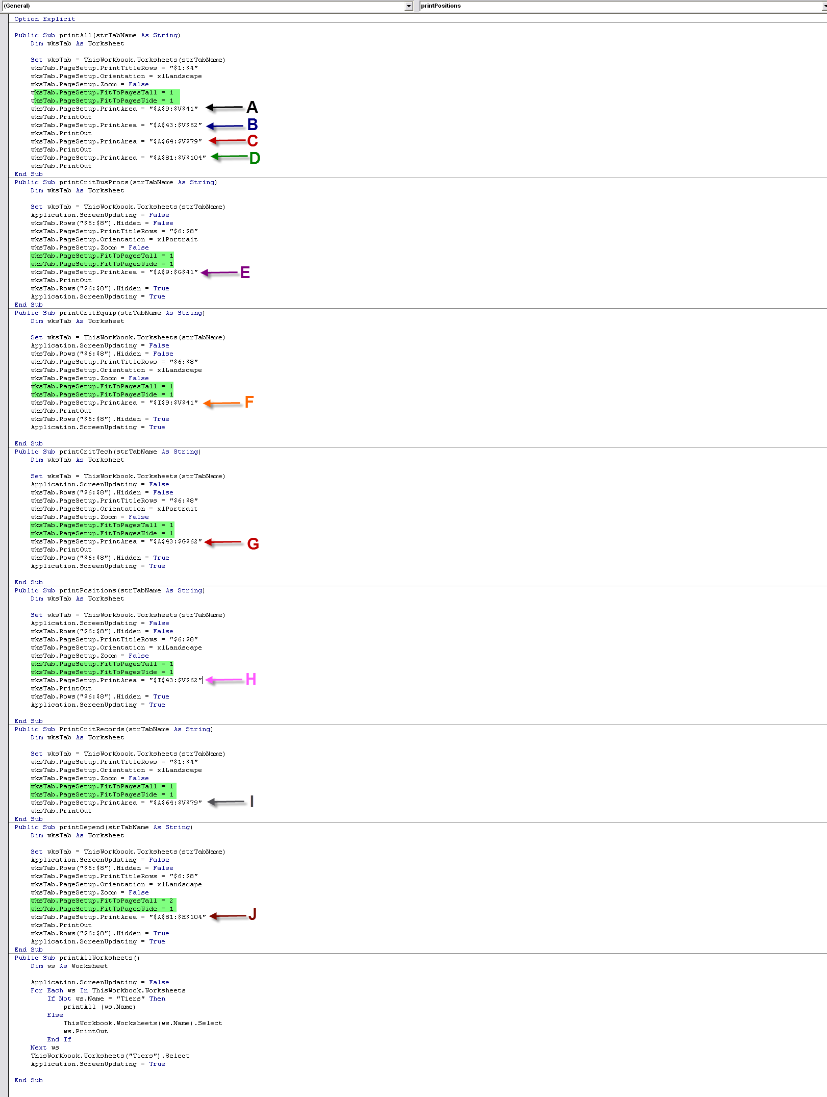
To update the printing modules in the Microsoft™ VB “code” for the Tiers Tab, modify the areas marked in Exhibit 11 with the new locations (as shown in the Exhibit 6 spreadsheet):
Black section (A) — Critical Business Processes and Critical Equipment and Resources sections should be updated with "$A$9:$V$ 41"
Blue section (B) —Technology & Equipment Critical Processess and Staff Positions sections should be updated with "$A$9:$V$ 62"
Red section (C) — Critical Records section should be updated with "$A$64:$V$ 79"
Green section (D) — Departmental Dependencies section should be updated with "$A$81:$V$104"

To update the printing modules in the Microsoft™ VB “code” for the Business Continuity Plan Tool Department Tabs, modify the areas marked in the Exhibit 11 with the new locations (as shown in the Exhibit 6 spreadsheet):
Purple section (E) — Critical Business Processes section (only) should be updated with "$A$9:$G$ 41"
Orange section (F) — Critical Equipment and Resources section (only) should be updated with "$I$9:$V$ 41"
Dark Red section (G) — Technology & Equipment Critical Processess section (only) should be updated with "$A$43:$G$ 62"
Pink section (H) — Staff Positions section should be updated with "$I$43:$V$62"
Gray section (I) — Critical Records section should be updated with "$A$64:$V$79"
Brown section (J) — Departmental Dependencies section "$A$81:$H$104"

The green highlighted areas controls the number of pages that each of the department section prints on. The purpose for adjusting the pages is to ensure that all data will be able to be read at a legible size. The more rows a departmental section has, the easier it will be to read if it is printed across multiple pages.
For example, in the Gray section (I) on Exhibit 11, 1 page tall by 1 page wide will print the Staff Positions section on 1 page, while on the Brown section (J) 2 pages tall by 1 page wide will print the Departmental Section on 2 pages.

Appendix E
Department Status Forms/Summary

Hold down your Ctrl key and click here to download the Department Status Forms/Summary or go to www.calhospitalprepare.org/continuity-resources.
(Note: File is large and can take a few minutes to open.)

Appendix F
Business Continuity Planning
(Presentation to Management)

Hold down your Ctrl key and click here to download the presentation or
go to www.calhospitalprepare.org/continuity-resources.
(Note: File is large and can take a few minutes to open.)

Appendix G
Utilizing Your Business Continuity Plan (Presentation for Department Managers)

Hold down your Ctrl key and click here to download the presentation or
go to www.calhospitalprepare.org/continuity-resources.
(Note: File is large and can take a few minutes to open.)

- Additional Example Plans/Resources

Example A
Good Samaritan Hospital: Business Continuity Guide for Critical Business Areas

BUSINESS CONTINUITY GUIDE
For Critical Business Areas

[Department Name]

[Date]

CONFIDENTIAL

© Good Samaritan Hospital
1225 Wilshire Blvd. • LA CA 90017
Phone 213.977.2201 • Fax 213.977.2262

Chapter 1: Introduction

Purpose
- This plan, mandated by HIPAA and TJC, will include identification of critical business functions and recovery timeframes, vital records/data, and critical computer applications.
- First response and recovery strategies for likely scenarios will be documented and staff trained. This plan shall be tested and updated annually.
- The [insert department] at Good Samaritan Hospital should plan and be prepared for a major disaster occurring in the Los Angeles area which would significantly damage and disrupt essential [insert department] operations at the hospital for an extended period of time.

Assumptions
- GSH is planning for the worst case scenario in Los Angeles – a large magnitude earthquake. This scenario assumes internal damage as well as a mass casualty influx.
- GSH must be prepared to operate without information systems for an extended period after a large earthquake – assume one month.
- The emergency response and triage will be directed by the Hospital Command Center (HCC) using the Hospital Emergency Incident Command System (HICS).
- The recovery timeframes to be used in planning are (a) 0-48 Hours; (b) 3-9 Days; and (c) 10-30 Days. Any function which does not need to be performed for 30 days is not considered critical.
- [insert department] performs essential functions [?] hours a day.

Chapter 2: Overview

Critical Business Functions
Identify the critical business functions in your area, i.e. functions needing to be performed within 30 days.

[insert description]

Recovery Time Objective (RTO)
How fast does each business function need to be up and running?

Critical Business Function | RTO

Recovery Point Objective (RPO)
Identify the RPO for either the critical business function or the department as a whole. The RPO is the amount of data that can be lost, or to what point in time do you need to restore data to? How much data could you lose and still remain operational and reconstruct your vital records, 24 hours worth? 48 hours worth? Less? More?

[insert description]

Critical Business Function | RPO

Vital Records
What are the vital records/data for the critical business functions? The records could be electronic, paper, or in other forms.

[insert description]

Critical Computer Applications
What are the critical computer applications used by your department or the critical business functions?

[insert description]

Chapter 3: Disaster Scenarios

Regional Disaster - External Only
Plan for a regional disaster that causes a mass casualty influx or other external impact to GSH without affecting information or internal systems.

[insert description of response actions]

Regional Disaster - External and Internal
Plan for a regional disaster, such as a large magnitude earthquake that causes internal damage and a mass casualty influx at the same time.

[insert description of response actions]

Loss of Information Systems
Plan for loss of information systems for an extended period of time. See Downtime Procedures chapters.

Scenario | Plan
Computer equipment damaged or destroyed (fell on floor, crushed)
All computer access to patient records not functional.
Other

Loss of Medical Gas
Plan for loss of medical gas for an extended period of time.

Scenario | Plan
Liquid gas tank damaged or destroyed
No estimated time for repair

Loss Of Utilities
Plan for loss of any or all utilities, i.e. power, water, gas, etc.

Scenario | Plan
No electricity (backup generator not working). No lights. No elevators.
No water. No gas.
Telephone lines down. Pager system down (including overhead).
ADMs (automatic dispensing machines) not functioning.

Loss of Primary Work Area
Plan for loss of primary work area due to whatever reason.

Scenario | Plan
Structural damage and flooding to department area and/or satellite areas.
Broken glass and supplies spilled on floor.

Other Scenarios
Plan for any other scenarios that would affect your department and/or critical business functions directly.

Scenario | Plan

Chapter 4: First Response

Contact List
Enter contact information for the department staff. May be included as an appendix.

MANAGEMENT STAFF
Name | Title | Primary # |  | Alternate # | Ext. | Beeper
Less than 12 miles from hospital – White |  |  |  | >12 and < 30 miles from hospital – Blue
Name | Team | ###-###-#### |  | Name | Team | ###-###-####
More than 30 miles from hospital – Red
Name | Team | ###-###-####

Recovery Team Members and Roles
Document the membership of the recovery team for the department. Determine the roles and responsibilities for the recovery team.

[insert description]

Disaster Activation and Notification
Develop disaster activation and notification procedures for a disaster during working and non working hours. Should the recovery team report to work in the middle of the night? What about the rest of the staff? Consider staff safety.

[insert description]

Retrieve Downtime Kits
Retrieve downtime kits stored in the _____________________ in the department. List the contents of the downtime kits. Design downtime procedures so that someone from outside your work area could perform the function. Develop detailed steps that document all necessary details, i.e. phone numbers, codes, etc. Document the downtime procedures for each critical business function in a different chapter for clarity.

[insert description]

Chapter 5: Critical Business Function 1 Downtime Procedures

0 - 24 HOURS
Describe the process by which the department will handle Critical Business Functions during the first 24 hours. If clinical, describe how the department will perform Critical Business Function for current inpatients, newly arriving patients, and the triage area (if applicable).

[insert description]
24 - 48 HOURS

Delayed Problems emerging within 48 hours
- List expected problems that will arise within 48 hours – run out of supplies, staff egress, etc.

Describe the process by which the department will handle Critical Business Functions for 24-48 hours. If clinical, describe how the department will perform Critical Business Function for current inpatients, newly arriving patients, and the triage area (if applicable).

[insert description]

3 - 9 DAYS

Delayed Problems emerging within 3-9 days
- List expected problems that will arise within 3-9 days – run out of supplies, staff egress, etc.

Describe the process by which the department will handle Critical Business Functions for 3-9 days. If clinical, describe how the department will perform Critical Business Function for current inpatients, newly arriving patients, and the triage area (if applicable).

[insert description]
10 - 30 DAYS

Delayed Problems emerging within 10-30 days
- List expected problems that will arise within 10-30 days – run out of supplies, staff egress, etc.

Describe the process by which the department will handle Critical Business Functions for 10-30 days. If clinical, describe how the department will perform Critical Business Function for current inpatients, newly arriving patients, and the triage area (if applicable)

[insert description]
Chapter 6: Critical Business Function 2 Downtime Procedures

0 - 24 HOURS

Describe the process by which the department will handle Critical Business Functions during the first 24 hours. If clinical, describe how the department will perform Critical Business Function for current inpatients, newly arriving patients, and the triage area (if applicable).

[insert description]

24 - 48 HOURS

Delayed Problems emerging within 48 hours
- List expected problems that will arise within 48 hours – run out of supplies, staff egress, etc.

Describe the process by which the department will handle Critical Business Functions for 24-48 hours. If clinical, describe how the department will perform Critical Business Function for current inpatients, newly arriving patients, and the triage area (if applicable).

[insert description]

3 - 9 DAYS

Delayed Problems emerging within 3-9 days
- List expected problems that will arise within 3-9 days – run out of supplies, staff egress, etc.

Describe the process by which the department will handle Critical Business Functions for 3-9 days. If clinical, describe how the department will perform Critical Business Function for current inpatients, newly arriving patients, and the triage area (if applicable).

[insert description]

10 - 30 DAYS

Delayed Problems emerging within 10-30 days
- List expected problems that will arise within 10-30 days – run out of supplies, staff egress, etc.

Describe the process by which the department will handle Critical Business Functions for 10-30 days. If clinical, describe how the department will perform Critical Business Function for current inpatients, newly arriving patients, and the triage area (if applicable)

[insert description]

Chapter 7: Critical Business Function 3 Downtime Procedures

0 - 24 HOURS

Describe the process by which the department will handle Critical Business Functions during the first 24 hours. If clinical, describe how the department will perform Critical Business Function for current inpatients, newly arriving patients, and the triage area (if applicable).

[insert description]

24 - 48 HOURS

Delayed Problems emerging within 48 hours
- List expected problems that will arise within 48 hours – run out of supplies, staff egress, etc.

Describe the process by which the department will handle Critical Business Functions for 24-48 hours. If clinical, describe how the department will perform Critical Business Function for current inpatients, newly arriving patients, and the triage area (if applicable).

[insert description]

3 - 9 DAYS

Delayed Problems emerging within 3-9 days
- List expected problems that will arise within 3-9 days – run out of supplies, staff egress, etc.

Describe the process by which the department will handle Critical Business Functions for 3-9 days. If clinical, describe how the department will perform Critical Business Function for current inpatients, newly arriving patients, and the triage area (if applicable).

[insert description]

10 - 30 DAYS

Delayed Problems emerging within 10-30 days
- List expected problems that will arise within 10-30 days – run out of supplies, staff egress, etc.

Describe the process by which the department will handle Critical Business Functions for 10-30 days. If clinical, describe how the department will perform Critical Business Function for current inpatients, newly arriving patients, and the triage area (if applicable)

[insert description]

Chapter 8: Critical Business Function 4 Downtime Procedures

0 - 24 HOURS

Describe the process by which the department will handle Critical Business Functions during the first 24 hours. If clinical, describe how the department will perform Critical Business Function for current inpatients, newly arriving patients, and the triage area (if applicable).

[insert description]

24 - 48 HOURS

Delayed Problems emerging within 48 hours
- List expected problems that will arise within 48 hours – run out of supplies, staff egress, etc.

Describe the process by which the department will handle Critical Business Functions for 24-48 hours. If clinical, describe how the department will perform Critical Business Function for current inpatients, newly arriving patients, and the triage area (if applicable).

[insert description]

3 - 9 DAYS

Delayed Problems emerging within 3-9 days
- List expected problems that will arise within 3-9 days – run out of supplies, staff egress, etc.

Describe the process by which the department will handle Critical Business Functions for 3-9 days. If clinical, describe how the department will perform Critical Business Function for current inpatients, newly arriving patients, and the triage area (if applicable).

[insert description]

10 - 30 DAYS

Delayed Problems emerging within 10-30 days
- List expected problems that will arise within 10-30 days – run out of supplies, staff egress, etc.

Describe the process by which the department will handle Critical Business Functions for 10-30 days. If clinical, describe how the department will perform Critical Business Function for current inpatients, newly arriving patients, and the triage area (if applicable)

[insert description]

Chapter 9: Recovery Strategies

Strategy Overview
Document any concerns that might impact recovery. These could include infrastructural problems, vendor agreements, possible hazards, or other factors that should be noted. For example, the Pharmacy should be concerned with delays in delivery of medications following a major earthquake, which could affect the ability to deliver adequate patient care.
Include plan for operational readiness on all shifts.

These should be different than Response Strategies. Response is how the department accommodates disruption; Recovery is how it returns to normal operations.

[insert description]

Recovery Strategy for Regional – External Only Disaster

[insert description]

Recovery Strategy for Regional – Internal/External Disaster

[insert description]

Recovery Strategy for Loss of IS for Extended Period (One Month)

[insert description]

Recovery Strategy for Loss of Medical Gas

[insert description]

Recovery Strategy for Loss of Utilities

[insert description]

Recovery Strategy for Loss of Primary Work Area

[insert description]

Recovery Strategy for Other

[insert description]

Recovering Vital Records
Detail how you would recover/restore vital records, i.e. electronic or paper. How would you deal with water damage or complete loss of paper or electronic records? How would you recover lost transactions? How would you recover work in progress? Detail steps.

Chapter 10: Plan Testing and Maintenance

Testing the Plan
Schedule a tabletop disaster exercise for key staff. Design a disaster scenario and likely problems that could occur, and exercise key staff for the critical business functions in a group problem solving process around a conference table. Piggyback recovery exercises on a scheduled hospital disaster drill required by the Joint Commission.

Schedule Regular Updates to the Plan
The last update to the plan was made on [insert date]. Updates should be done at least quarterly for the contact lists and at least every six months for the recovery strategies and related information. The next scheduled update is [insert date].

Plan Distribution
There are [insert #] copies of this plan in distribution. The holders of this departmental copy of the plan are:

- Copy #1 –
- Copy #2 –
- Copy #3 –
- Copy #4 –

Example B
Kaiser Recovery Checklist

Kaiser Recovery Checklist

Objective
This document supports and supplements the Business Recovery Critical Action Sheet. In the event your department is directed to invoke its recovery plan, this document acts as a guideline to the departmental recovery process and is not intended to be an inflexible process or procedure.

Introduction
Each Kaiser Permanente hospital maintains a detailed Disaster/Emergency Plans that includes most considerations for how the healthcare organization responds to events that may disrupt service levels that meet the expectation of our Members and Staff. Events include but not limited to the following:
- Significant Medical Event
- Loss of Building Access
- Loss of Power
- Loss of Voice
- Loss of Network Applications

Stage 1 - Immediate Response, Alert, and Mobilization

Describe general instruction on evacuation and activation of emergency services, (police, fire, security etc). Note: any references to calling “9-1-1” must be written as “9-9-1-1” if dialing a “9” is needed at your facility. Do not include the names of phone numbers of individuals in the Tasks & Procedures section because it is too difficult to keep names and numbers current here. Instead use functional titles such as “Safety Coordinator” or “Recovery Team Leader”.

Alert & Mobilization
1.1.1 Procedures for Events during Business Hours
- All staff will be notified by the Managers. (Refer to the phone contact list)
- Management team will assess the situation and instruct staff of the assessment outcome.
- Contact Security of mobilization and alternate site location.

1.1.2 Non-Business Hours
- All staff will be notified by the Department Manager. (Refer to the phone contact list)
- Management team will assess the situation and instruct staff of the assessment outcome.
- Contact Security of mobilization and alternate site location.

1.1.3 Emergency Escalation Procedures
- If notification is initiated by Local/Regional Security:
  - The staff member that was notified by Local/Regional Security will contact Department Management.
  - The Management team will assess the situation and instruct staff of the assessment outcome.
- If notification is initiated by Department:
  - Follow procedures identified in Stage 1.1.1

1.1.4 Alert Members of Your Business unit/department Recovery Team
- See phone contact list
1.1.5 Media Management Procedures
- Refer all media inquires to Public Affairs

Recovery Plan Activation
1.2.1 Activation Procedures
- Regional Emergency Operations Center (EOC) assesses the event and determines if recovery is necessary. If recovery is not necessary, return to normal operations. If recovery is necessary:
  - Notify Staff that the recovery plan has been activated.
  - Management and Staff review recovery strategies.
  - Management and Staff implement recovery strategy processes.

1.2.2 Contact Staff and Advise
- Follow procedures identified in Stage 1.1.1

1.2.3 Notify Internal Departments, Customers and Other Parties
- Notify departments, internal and external sources which your department depends on work inflow/ outflow to time sensitive operations. Refer to Recovery Plan Sections:
  - Work Inflow – Dependencies and Impacts
  - Work Outflow – Dependencies and Impacts

Stage 2 – Prepare to Move to Alternate Site

Activate Alternate Site
2.1.1 Confirm Recovery Location
- All staff is equipped to work from home until an alternate site is established.

2.1.2 Prepare For Relocation
- All staff is equipped to work from home until an alternate site is established.

2.1.3 Determine Available Employees and Supplies
- Identify available employees and/or volunteers to assist in relocation coordination. Refer to Recovery Resources Report

2.1.4 Coordinate site requirements with HEOC and/or Relocation Site
- Once an alternate site is established, work with the recovery site KPIT point-of-contact to ensure KPIT requirements are met.
- Ensure that appropriate access is provided for recovery personnel including but not limited to parking access, department access, etc.

2.1.5 Notify Employees of Alternate Site Location and Schedule
- Management will notify staff of the alternate site and staff schedules. (Refer to the phone contact list)

2.1.6 Coordinate Staff Transportation Requirements (if necessary)

Stage 3 – Establish Alternate Site

Set Up Alternate Site
3.1.1 Establish viability of Workstations, Data, and Connectivity in collaboration with KPIT requirements available
- Refer to Recovery Plan Section:
  - Critical Applications Used

3.1.2 Meet with Your Team Members to Evaluate Status
- All staff will be notified by the Manager. (Refer to the HCM phone contact list)

3.1.3 Report Alternate site status and needs as appropriate
- Any needs or concerns will be forwarded to Management
- The Management team will evaluate the alternate site’s status.
- Management will forward all needs and concerns to the HEOC and/or alternate site point-of-contact.

Stage 4 – Resume Business Function at Alternate Site

Resume Business Functions
4.1.1 Identify Backlogged and Lost Transaction
- Refer to Primary Functions and Work-in-Progress Impacts section
- Complete lost transaction recovery process
- Evaluate restoration process

4.1.2 Inform Internal Departments, Customers and Other Parties of Alternate Site
- Confirm Customer Connectivity. Refer to the following Recovery Plan sections
  - Work Inflow Dependencies and Impacts
  - Work Outflow Dependencies and Impacts

4.1.3 Resume Business Functions
- Identify critical backlogged and lost transactions. Complete lost transaction recovery process.
  - Refer to the “Recovery Strategies Detail” section
- Notify internal departments, customers and other parties of business resumption.
  - Refer to Stage 4.1.2
- Resume normal business functions.
- Continue to meet with Team Members to get updates on status and needs, and to review the Recovery Action Plan.
- Regularly report status and needs to the Department Manager.

4.1.4 Report status to HEOC and/or REOC as appropriate
  - Georgia Region EOC

Stage 5 – Prepare to Return to Home Site

Prepare Home Site
5.1.1 Confirm Home Site Location
- Contact Service Area Facilities Departments to ensure Home Site is available

5.1.2 Prepare For Relocation
- Department Management team will assess the situation and instruct staff the return to home site

5.1.3 Determine Available Employees and Supplies
- Identify available employees and/or volunteers to assist in relocation coordination Refer to the following Recovery Plan section:
  - Recovery Resources Report

5.1.4 Coordinate site requirements
- Contact Service Area Facilities
- Contact KPIT to ensure department requirements are met. Refer to Recovery Plan Section:
  - Critical Applications Used

5.1.5 Notify Employees of Home Site Location and Schedule
- Management will notify staff of the return to normal operation schedules. (Refer to the phone contact list)
- Notify HEOC and/or relocation site point-of-contact of department employee work schedule

5.1.6 Coordinate Staff Transportation Requirements (if necessary)
- All staff is equipped to work from home if transportation is not available.

Stage 6 – Establish Home Site

Set Up Home Site
6.1.1 Establish viability of Workstations, Data, and Connectivity
In collaboration with KPIT, test and ensure IT and Communication requirements at Home Site are operational. Refer to Recovery Plan Section
  - Critical Applications Used

6.1.2 Meet with Your Team Members to Evaluate Status
- All Staff will be notified by the Manager to evaluate the recovery status. (Refer to the phone contact list)

6.1.3 Report Alternate site status and needs as appropriate
- Contact the appropriate departments to report department status and needs.

Stage 7 – Resume Business Function at Home Site

Resume Business Functions
7.1.1 Identify Any Backlogged Work-in-Progress and/or Lost Transactions
- Refer to Primary Functions and Work-in-Progress Impacts section
- Complete lost transaction recovery process
- Evaluate restoration process

7.1.2 Inform Internal Departments, Customers and Other Parties of Alternate Site
- Confirm Customer Connectivity. Refer to the following
  - Work Inflow Dependencies and Impacts
  - Work Outflow Dependencies and Impacts

7.1.3 Resume Business Functions
- Identify critical backlogged work-in-progress and/ or lost transactions
- Complete lost transaction recovery process. Refer to Recovery Plan section:
  - Recovery Strategies Detail
- Notify internal departments, customers and other parties of business resumption.
  - Refer to Stage 4.1.2
- Continue to meet with Team Members to get updates on status and needs, and to review the Recovery Action Plan.

7.1.4 Report status to REOC and/or HEOC as appropriate
Regional EOC will remain active until recovery is complete

Stage 8 – Evaluate Recovery Process and Deliverables

8.1.1 Debrief Team Member and affected staff
- Discuss summary of incident
- Identify what response activities went well
- Identify what response activities need improvement
- Recommend future actions

8.1.2 Conduct customer evaluation (optional)

8.1.3 Write an After-Action Report
- Base leanings from staff debriefings and customer evaluations
- Deliver After-Action Report to the National Threat Assessment Department within 30 days of the incident

8.1.4 Conduct stress management, debriefings and meetings as necessary
- Contact the local EAP for assistance

Example C
SHARPS Risk Assessment Matrix

RISK ASSESSMENT MATRIX
DEPARTMENT-SPECIFIC ACTION PLAN

KEY CODES

Priority (P): C = Critical E = Essential, NE = Non-essential
Recovery Requirement (RR): I = Immediate D = Delayed DEF = Deferred
Vulnerability (V): HV = Highly Vulnerable V = Vulnerable NV = Not vulnerable

Priority: prioritize for re-initializing a critical services function if it is lost
Critical (C): Cannot do without or it is a function that is vital to the department and/or may pose a life safety risk
Essential (E): Non critical, difficult to operate without, but the department could function for a period of time
Non Essential (NE): Disruption would merely be an inconvenience

Recovery Requirement: prioritize as to the maximum allowable recovery time of the critical services function listed
Immediate (I): 0 to 24 hours (may require immediate alternate site)
Delayed (D): 24 hours to 7 days (may need a prearranged site that could be used for a short period of time)
Deferred (DEF): Beyond 7 days (no immediate need for offsite location)

Vulnerability: prioritize as to the likelihood of losing the critical services function listed
High Vulnerable (H): Great risk of experiencing a threat or hazard
Vulnerable (V): May experience a threat or hazard
Not Vulnerable (NV): Threat or hazard not likely to occur.

NUMBER OF EMPLOYEES
Could the department scale back the number of employees?
Could the department employees work from home? If so how many employees could work from home?

DEPARTMENT CONTACT
Record the department name, name of the employee and telephone number who will assist the department.

PLAN
Describe the Action Plan including the costs associated with the plan.

RISK ASSESSMENT MATRIX
DEPARTMENT-SPECIFIC ACTION PLAN

Department:
Contact Name:
Telephone:

FUNCTION | P | RR | V | NUMBER OF EMPLOYEES | DEPARTMENT CONTACT | ACTION PLAN (Include Costs)
Electrical Power
Lighting
HVAC
Water
Sanitation

FUNCTION | P | RR | V | NUMBER OF EMPLOYEES | DEPARTMENT CONTACT | ACTION PLAN (Include Costs)
Communication Tools by Type:
- Telephones
- Facsimile
- Email
- Cell Phones
Elevators

Critical Supplies by Type:
- Clerical
- Other
Computers
- Specific software applications or programs
- Hardware
Other

Example D
Sample Business Continuity
Planning Presentation

Hold down your Ctrl key and click here to download the presentation or
go to www.calhospitalprepare.org/continuity-resources.
(Note: File is large and can take a few minutes to open.)

